

KULLIYYAH OF INFORMATION AND COMMUNICATION TECHNOLOGY

**INFO 2303 – WEB TECHNOLOGIES**

**Semester 2 - 2019/2020**

**PROJECT PART 3 (“*Soul of D’ Relax Resort* ”)**

**Section:** *1*

**Group Members :** Young Tech

|  |  |
| --- | --- |
| **Name** | **Matric Number** |
| Adzreen Nulsyazwan Bin S.Nadzeer | 1817873 |
| Muhammad Amirul Aiman Bin Yusoff | 1826557 |
| Ahmad Irfaan Helmi Bin Jaffar | 1828459 |
| Muhammad Aidil Fahmiey Bin  Osman | 1819369 |
| Muhammad Afiq Bin Munir | 1818931 |

**Lecturer *:*** *Dr. Marini Binti Othman*

# Home

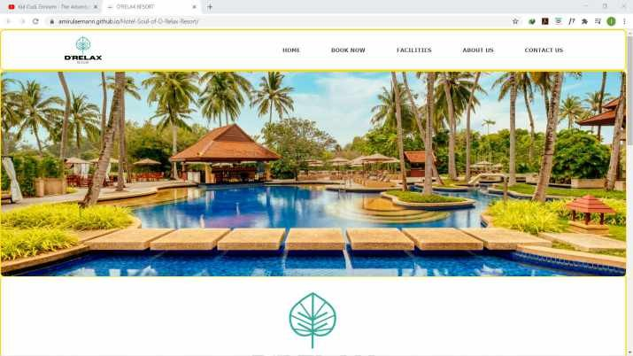Figure 1.1 until figure 1.3 show the detail of our home page.

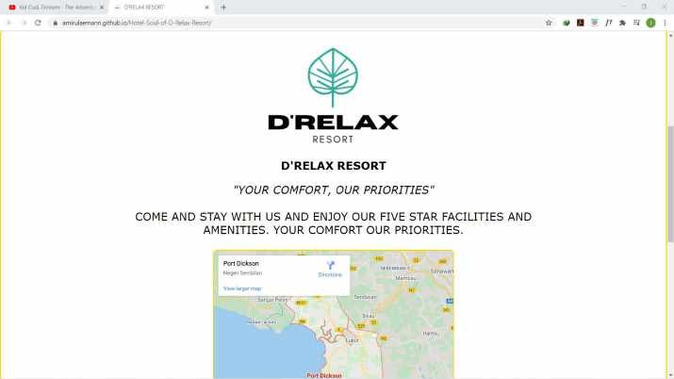Figure 1.1

Figure 1.2

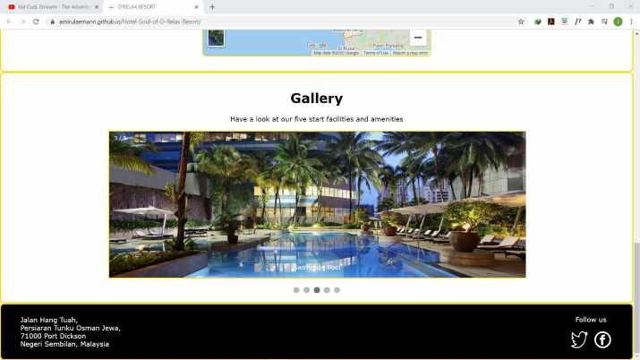

Figure 1.3

# Book Now

Figure 2.1 until figure 2.2 show the detail of our book now page.

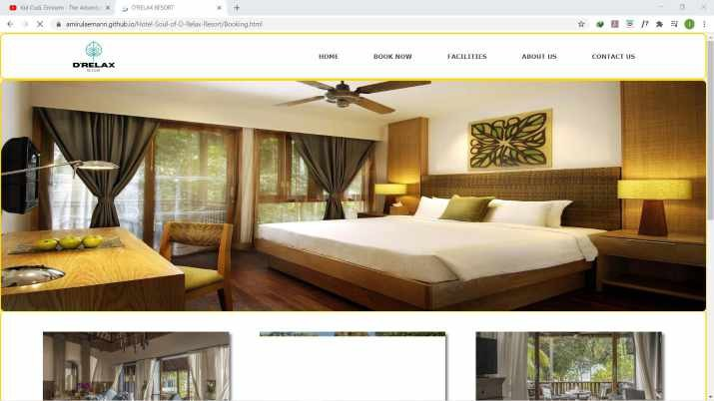

Figure 2.1

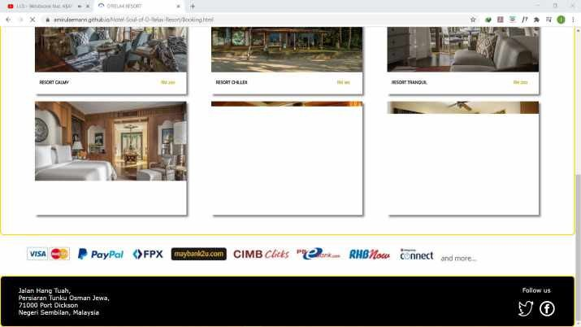

Figure 2.2

Figure 2.3 until figure 2.4 show the detail if customer want to book room in our book now page.

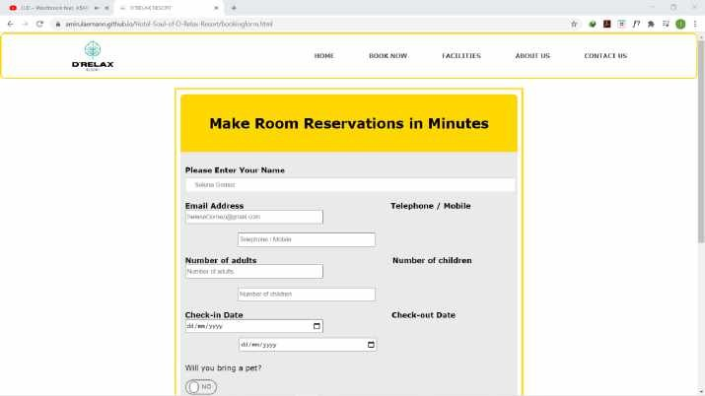

Figure 2.3

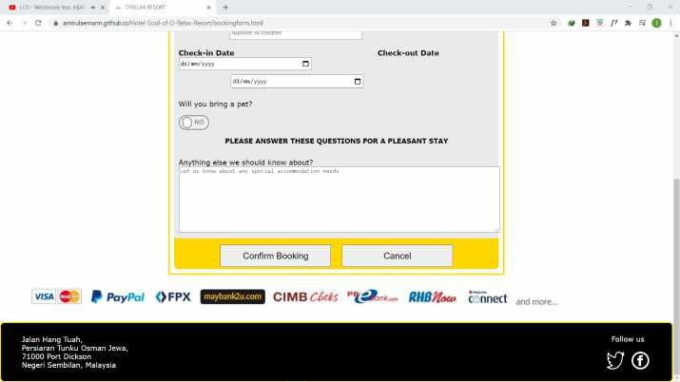

Figure 2.4

1. Facilities

Figure 3.1 until figure 3.2 show the detail of our facilities page.

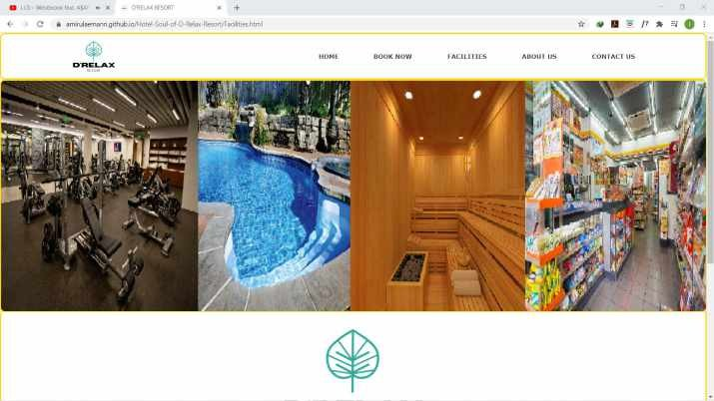

Figure 3.1

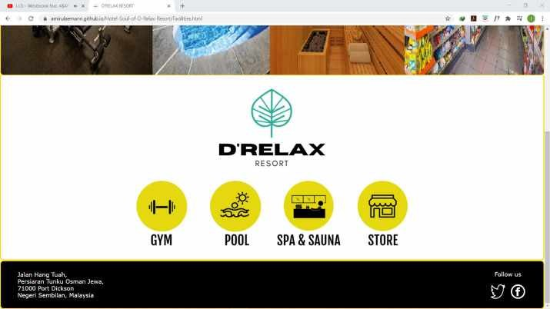

1. Gym

Figure 3.2

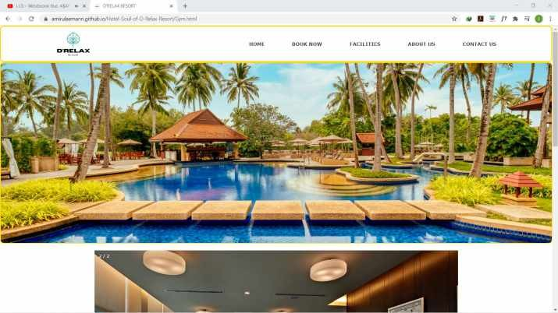Figure 4.1 until figure 4.4 show the detail of our gym page.

Figure 4.1

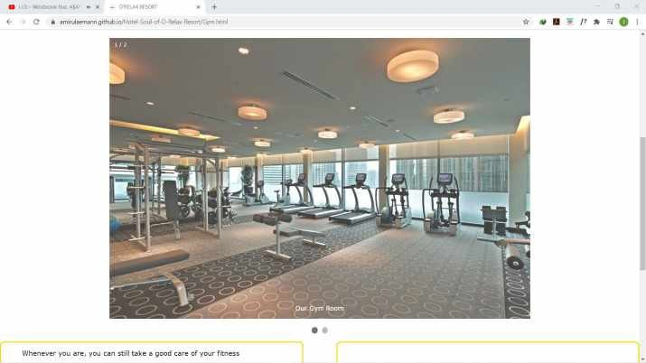

Figure 4.2

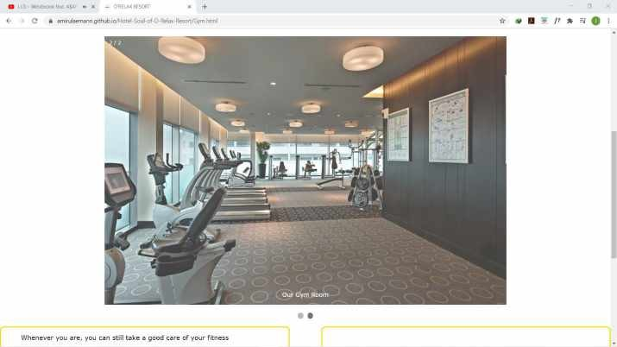

Figure 4.3

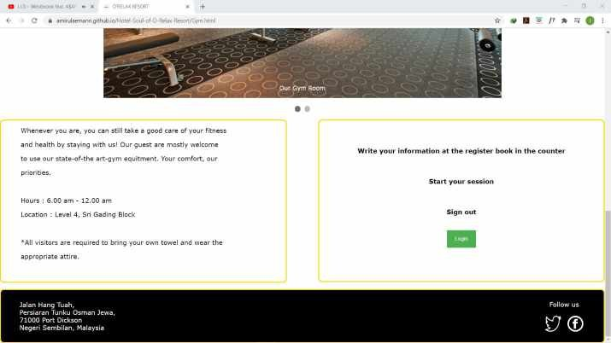

1. Pool

Figure 4.4

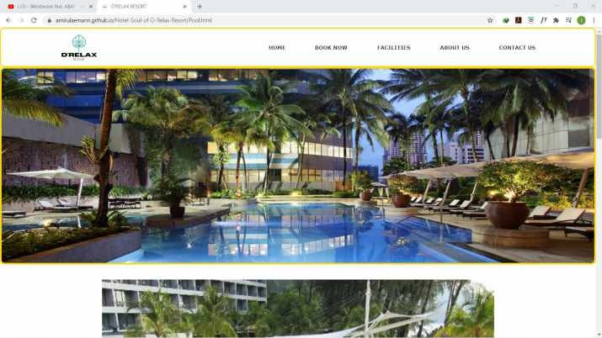Figure 5.1 until figure 5.3 show the detail of our pool page.

Figure 5.1

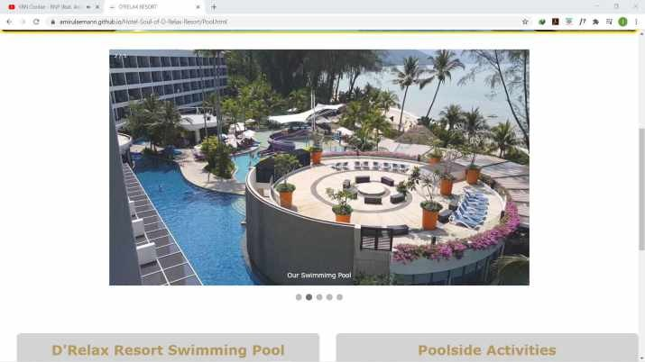

Figure 5.2

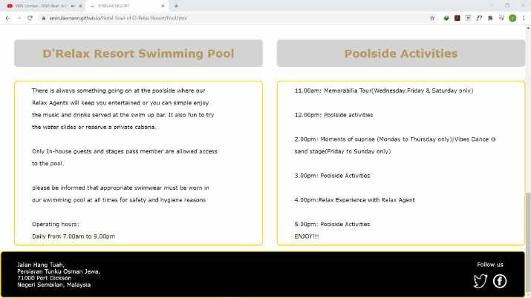

Figure 5.3

1. Spa & Sauna

Figure 6.1 until figure 6.3 show the detail of our spa & sauna page.

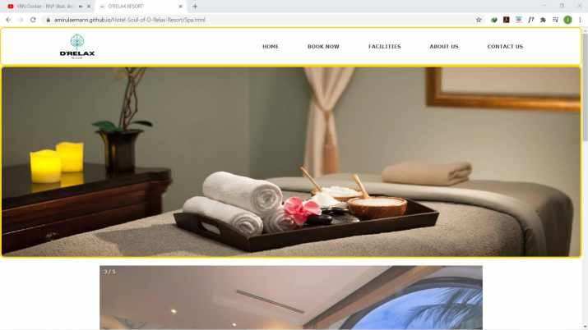

Figure 6.1

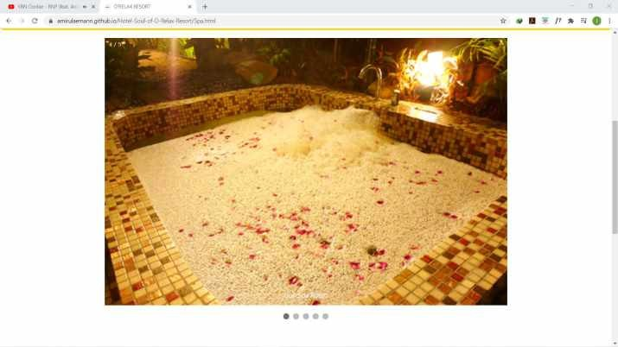

Figure 6.2

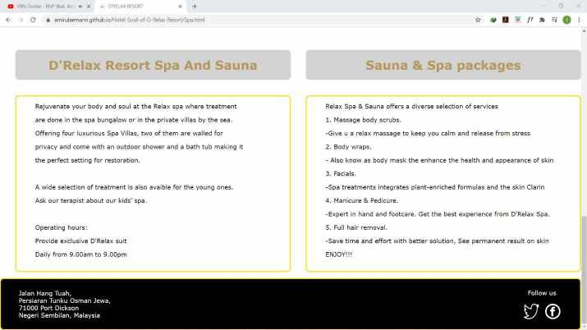

1. Store

Figure 6.3

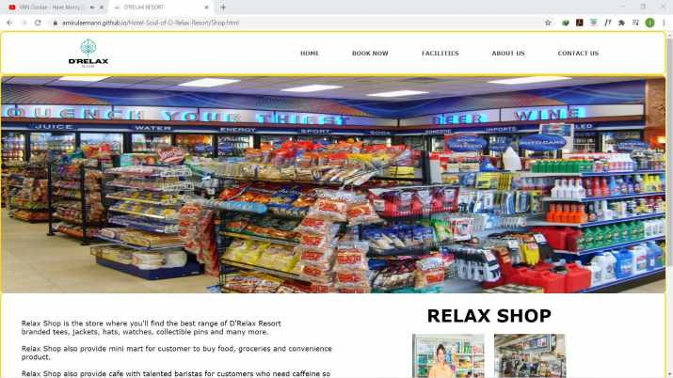Figure 7.1 until figure 7.2 show the detail of our store page.

Figure 7.1

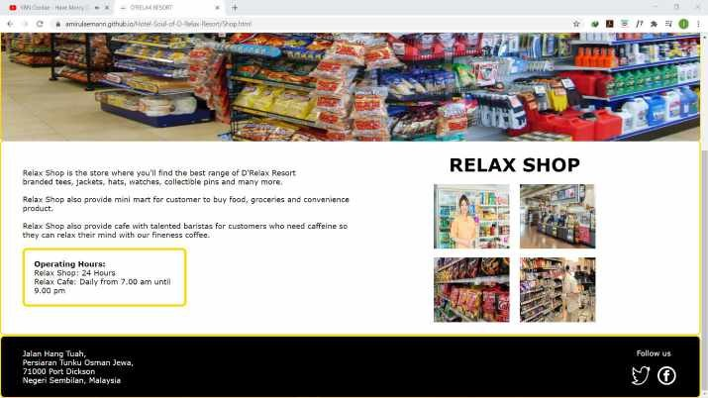

Figure 7.2

1. About Us

Figure 8.1 until figure 8.4 show the detail of our about us page.

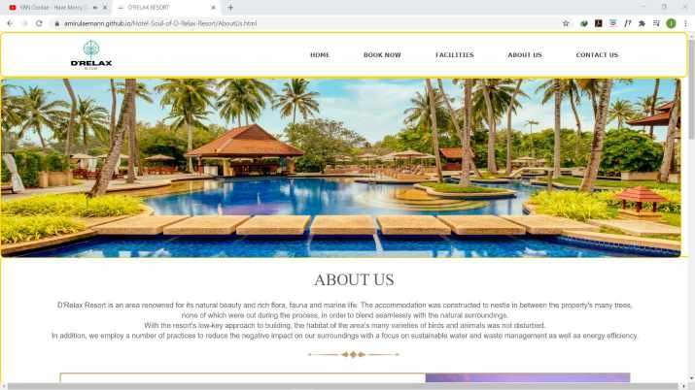

Figure 8.1

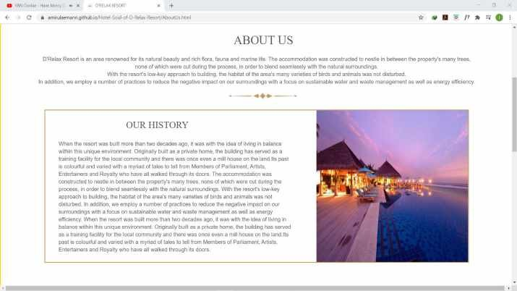

Figure 8.2

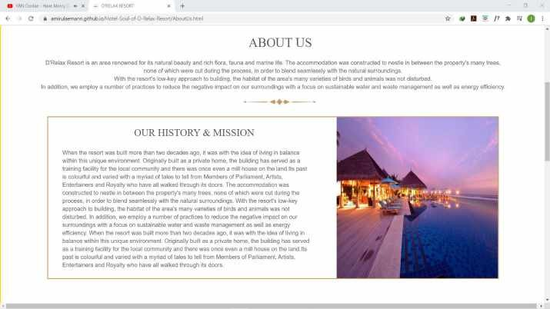

Figure 8.3

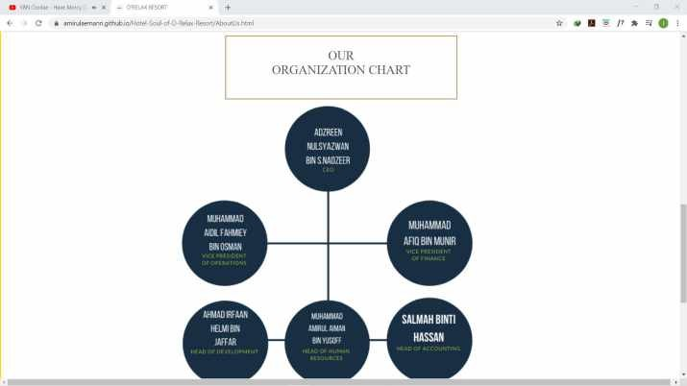

Figure 8.4

1. Contact Us

Figure 9.1 until figure 9.4 show the detail of our contact us page.

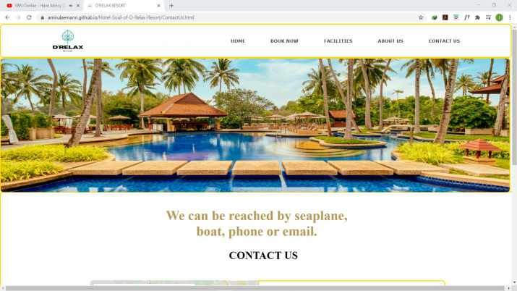

Figure 9.1

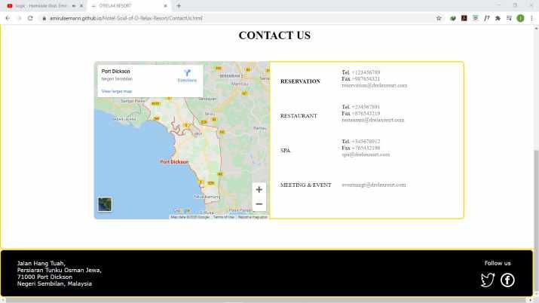

Figure 9.2

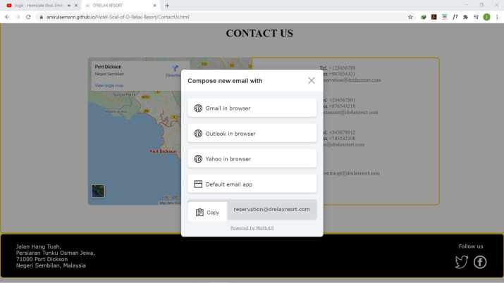

Figure 9.3

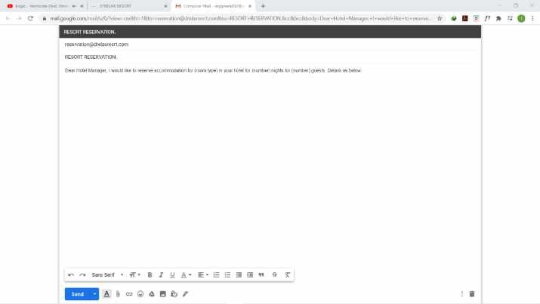

Figure 9.4